A Sports development program for kids 2-18yrs old!

WELCOME TO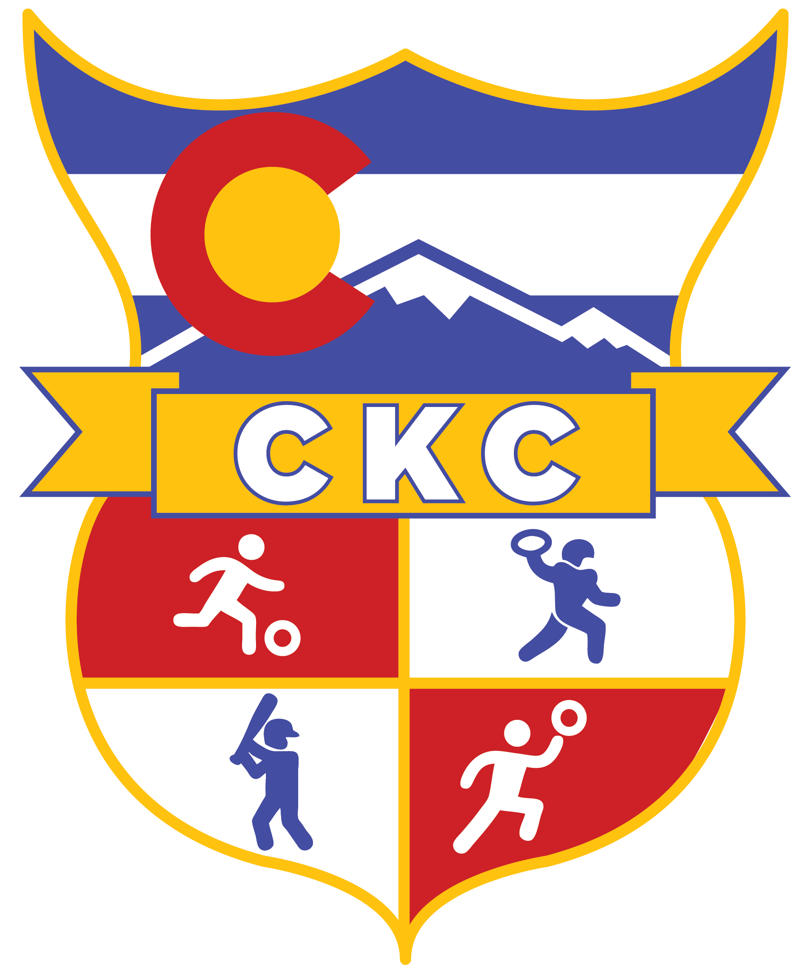

The objectives we are striving to accomplish here are:
- Running control
- Balance
- Ball control- hand-eye and eye-foot coordination
 Socializing/listening to directions
- Kicking/throwing control
- Fitness and FUN!

There are many different ages and levels of camps offered through the Colorado Kids Camp:

The Camp for 2yrs is a parent participation camp. We ask that the parents take this time to bond with their children by interacting and joining in with the activities. A child never has to partake in something they don’t want to. If this is the case, please feel free to explore any of the props we have so that your child feels comfortable until the next activity. FUN is our main objective!
The Camps 3yrs up to 9yrs old are an individual’s camp that works on following directions and listening skills. We ask that the parents please help their child focus on the instructor and on socializing with the other children by watching from the sidelines.
Our intent is to engage the kids in the games that develop their skills without them feeling like it is something they HAVE to do. If a child is not interested in a particular game, that’s OK. They don’t have to do anything they don’t want to do. If your child is shy about getting involved and needs you, you are more than welcome to come out on the field and join with you child for however long he/she needs.
All camps are structured and have a fun filled curriculum each week, so it’s very important to make it to each camp that way your child doesn’t feel lost or behind.

PLEASE HAVE YOUR CHILD WEAR COMFORTABLE SHOES, CLOTHING AND BRING A WATER BOTTLE TO ALL CLASSES. Contact me on my cell for cancellations due to weather!

Your child will be able to make up one class per session. In order to qualify for a make-up class, you must let us know in advance when your child will be absent. Make-ups are done on a space available basis. NO make-up will carry over into the next session.

Please feel free to ask me any questions you may have after class.
You can also call me at: 720-629-4179 or email me at: Susie@ColoradoKidsCamp.com
Thank you for being a part of Colorado Kids Camp!

Susie Ohle Elmer, Director

